Avida-ED Quick Start User Manual

I. General Avida-ED Workspace
Viewer
chooser
Freezer
Lab
Bench

(A) Viewer chooser buttons
Switch between lab bench views
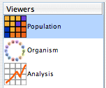

(B) Lab bench
Three lab bench options:
1. Population View Lab Bench (Petri dish & stats viewpanes)
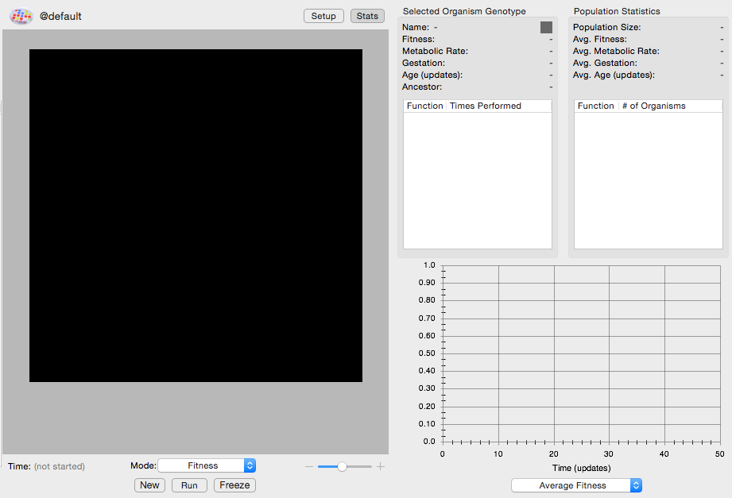

2. Organism View Lab Bench (Genetiscope)
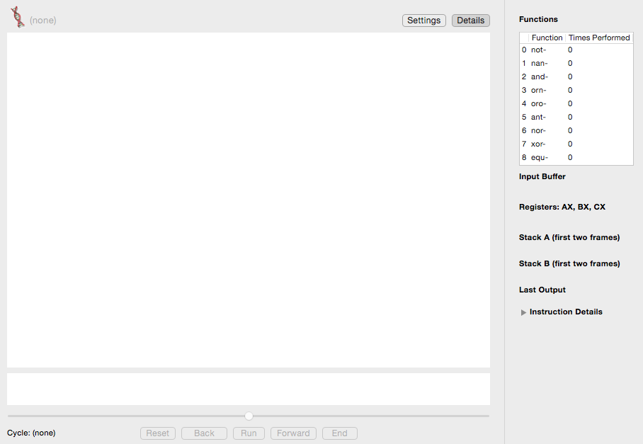

3. Analysis View Lab Bench (Data graphing & analysis)
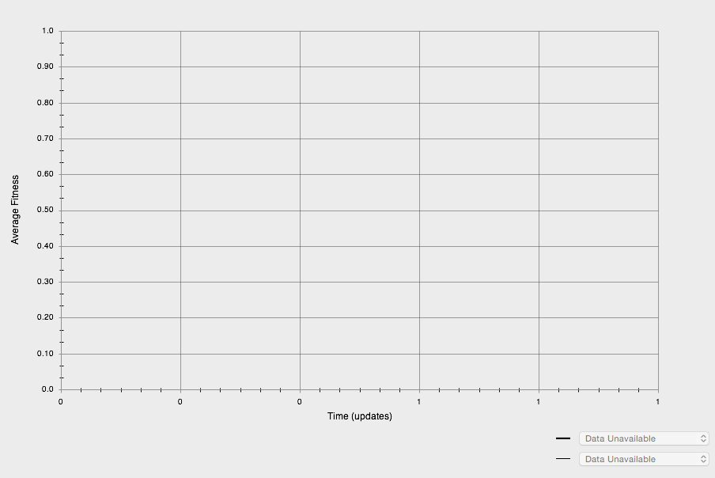

(C) The Freezer
• Storage shelves for:
- Configured Petri dishes (environmental settings but no organisms)
- Individual organisms removed from a Petri dish
- Populated Petri dishes (fixed environment settings and frozen organisms)
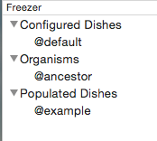
• Drag and drop freezer items to or from an open lab bench.
• Right-click (Ctrl-click) or double-click item in freezer to rename it (except default items)
• Click a disclose triangle to hide or show lists of items
• Export selected item. [MENU File -> Export Freezer Item…]

II. Lab Benches

(1) Population Viewer (“Petri Dish” & environment settings)

Functionality
- Evolve a population in a Petri dish
- Click on an individual organism and observe its stats
- Observe whole population stats in real time
- Graph population stats in real time

Basic Controls
- Drag a Petri dish (configured or populated) or one or more organisms into the Petri dish bench from the freezer to begin a new run.
- Setup/Map button: Switch between Petri dish front view and its environment settings.
- Export data to comma-delimited file. [MENU File -> Export Data…]
- Save images of population or graph in viewer [MENU File -> Export Graphics…]
- Import or Export a dish or organism. [MENU File -> Import/Export Item…]
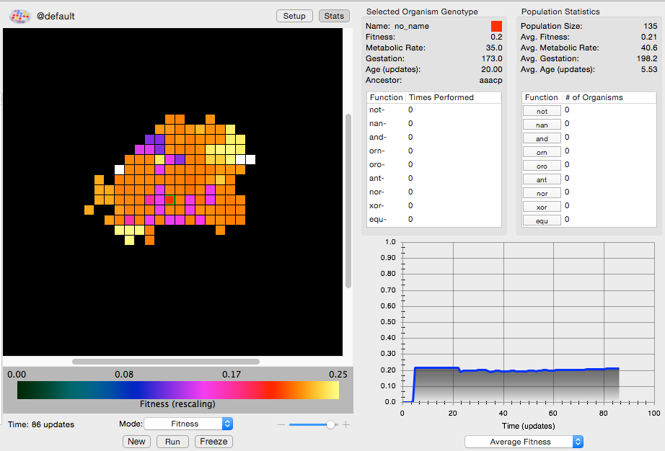
Dish viewpane (front)
Organism clicked on stats report
Population statistics panel
Population data graph

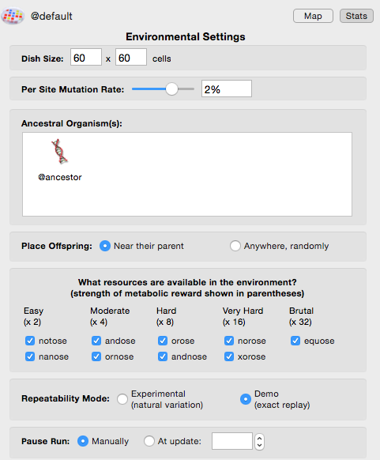
Buttons to flip to Petri dish front map and to hide/show side stats panel
Dish
viewpane (rear) Environment settings

Dish viewpane (front)
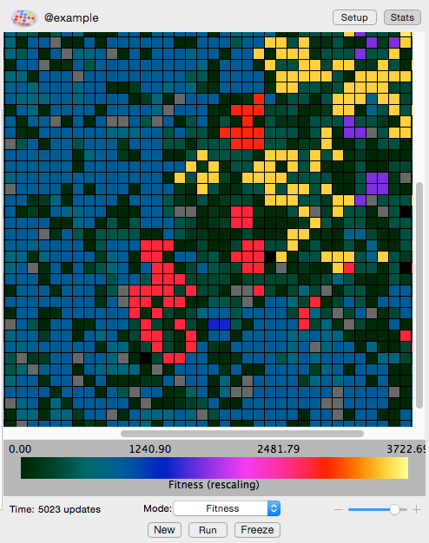
Population icon & name
Zoom level &
control
New Experiment and Run/Stop buttons
Update #
Pull down menu to change what information is being displayed

Color scale legend
Switch over to environmental setup controls; Hide/show stats panel
Petri dish grid
Freeze dish/organism button

- Population icon & name: Drag icon to freezer to save either the populated dish or just the dish environmental configuration. Click name to rename.
- Setup button: Go to environmental settings for this Petri dish.
- Stats button: Hide/reveal stats side panel for this dish.
- Petri dish map: More or less of the map is visible depending upon the size of the grid. Use scroll bars and/or zoom control if grid extends beyond window.
- Color Scale Legend: During a run, the color scale will automatically adjust as numbers increase or decrease. [“Rescaling” will appear in parentheses.] The spectrum will thus always show relative values, but particular colors will represent different absolute values as a population evolves. Special colors: Black indicates an empty cell and white indicates a cell whose value is above the maximum portrayed on the scale (as the scale readjusts to accommodate this new value it will be colored appropriately). Grey indicates that a cell is occupied, but that its value has not yet been determined (must wait for replication).
- Time - Avida internal time; in number of updates since the beginning of a run. This is a constant internal time; it does not correspond to external time because updates take longer for larger populations.
- Mode menu: Pull down menu to select a feature of the population to indicate by color.
Options: Fitness, Gestation Time, Metabolic Rate, Ancestor Organism.
- New button: Ends the current run (after offering to discard or save it) and then resets the Petri dish for a new experiment.
- Run/Stop button: Starts and temporarily stops a run.
- Freeze button: Save the population and/or environmental settings to the freezer.
- Zoom: Set the zoom level for the Petri dish. Use scroll bars if zooming in causes the grid to extend beyond window.

Shortcuts:
- Click on an organism in the Petri Dish and drag it to the Freezer to save it.
- Click on an organism in the Petri Dish or the Freezer and drag it to the Organism Viewer icon in the Viewer Chooser to open it directly in the Organism Viewer.
- Click on the Petri Dish icon in the Petri Dish and drag it to the Freezer to save it.
- Click on the Petri Dish icon in the Petri Dish or on the name of a populated dish in the Freezer and drag it to the Analyze Viewer icon in the Viewer Choose to view it directly in the Analyzer without having to save it to the Freezer first.
- Click on an item in the Freezer and drag it to the trash can icon to delete it.

Stats viewpanes

Organism Clicked on Statistics Report
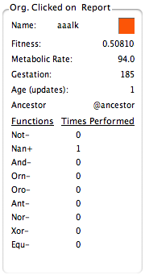

Name: Upon initial replication, Avida-ED automatically assigns temporary placeholder names to new varieties of Avidians as they evolve in a population. (New kinds of organisms that have not replicated, perhaps because they are not viable, are listed as no_name.) The square’s color matches the color of the selected Avidian in the current Petri dish grid.
Basic Statistics: The listing of stats related to the selected organism are updated as the population is running: Fitness, Metabolic Rate, Gestation, Age (updates).
Functions list: Metabolic functions, listed in ascending order of complexity, that the organism may have evolved the ability to perform. If “Times Performed” is “0” the organism has not performed that function yet in this lifetime (or never does). Organisms get more energy (SIPs) if they perform more complex functions.

Population statistics
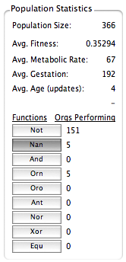
Click buttons to highlight orgs in dish that have these phenotypes
- These are the same functions as in the Org. Clicked on Report, but data is given for the population as a whole.
- Click a single function button to highlight organisms in the dish that have the given function. Clicking two or more function buttons highlights organisms that have ALL the selected functions.

Population data graph
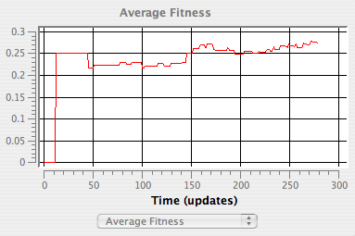
Pull down menu for property to graph

- Pull down property menu: Pick the property of the population to graph in real time. Options include: Average Metabolic Rate, Average Fitness, Average Gestation Time, and Number of Organisms in the population.
- Vertical axis: Units change depending upon property being graphed. The scale dynamically changes during a run to accommodate the evolving population.
- Time axis: Time, in updates, since beginning of run of this population.

Environmental settings & controls
Buttons to show Petri dish map; show/hide stats side panel
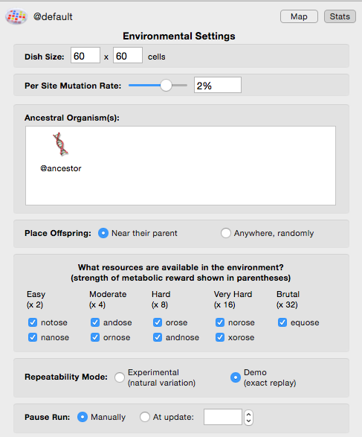
Petri Dish size
setting
Ancestral seed organism(s)
Exact repeatability control
Per Site Mutation Rate & slide control

Environmental resources settings
Offspring placement setting
Pause Run setting

- Per site mutation rate: This rate reflects the percent chance that an instruction is incorrectly copied. So, if the per site mutation rate is 1%, there is a 1% chance that when an instruction is copied, it will end up as any one of the 26 possible instructions (one of which is itself, so it could ‘mutate’ back to itself). With a 1% per site mutation rate, if 100 instructions are copied one of them will be mutated on average (although this number could be higher or lower in any instance).
- Dish size: Sets the maximum number of Avidians that can exist in the population. The two numbers specify the number of Avidians per row, and per column. So, 10 x 10 = a population of 100 organisms.
- Ancestral seed organism(s): The organism(s) the population begins from. Drag in or out additional organisms at the beginning of a run. If seed organisms are added to the dish using this setting they are automatically placed in a set pattern on the Petri Dish (e.g. in the exact center for a single organism or at the points of an equilateral triangle for three organisms). If you want to place organisms manually at specific points on the dish, drag them there on the front map side of the dish instead of seeding them here.
- Environmental Resource Settings: Avidians can receive extra energy if they evolve the ability to “metabolize” nutrients. Here you can set what nutrients are available in the environment.
- Exact Repeatability: Many steps in an Avida evolutionary run happen randomly (e.g. what mutations will occur in the genome, into what cell a new organism will be placed at division), so each run will be slightly different even with the same general environmental values, as in nature. This is the default setting. However, if you need to precisely repeat a run (e.g. for a demonstration) you can switch this to exactly replicate the sequence with the same mutations and values.
- Offspring placement: When an offspring is born, it can either be placed (at random) in one of the eight cells adjacent to its parent, or anywhere (at random) in the population. If the cell is already occupied, the organism there is overwritten.
- Pause Run Manually/Automatically: If you set a specific number ahead of time, the run will pause when this many updates have passed. If you set the run to stop manually, it will continue indefinitely until it is paused using the button under the Petri dish.

(2) Genetiscope (Organism genome viewer)

Functionality
- Observe the genome of an individual organism.
- Play a movie of the genome instructions’ operation.
- Check aspects of an organism’s phenotype, including its viability.
- Save viewer images.

Basic Controls
- Drag an organism from the freezer. (A progress bar will indicate that the organism is being readied for viewing.)
- Press Run/Stop to start/stop the movie of the genome’s execution. Use the scrub bar to move back and forth in the movie, or press Back or Forward to move just one instruction at a time. End jumps to the final instruction. Press Reset to reset the genome to the start position for a fresh execution.
- Click the DNA icon of the parent or daughter cell and then drag into the freezer to save that genome. The daughter cell icon will only appear after division.
- Press Settings button for the viewer settings. Use the settings to change the per site mutation rate and the repeatability mode.
- Press Details to show or hide the side panel, which lists the org’s functions and shows the bit-level operations of the genome instructions that produce them.

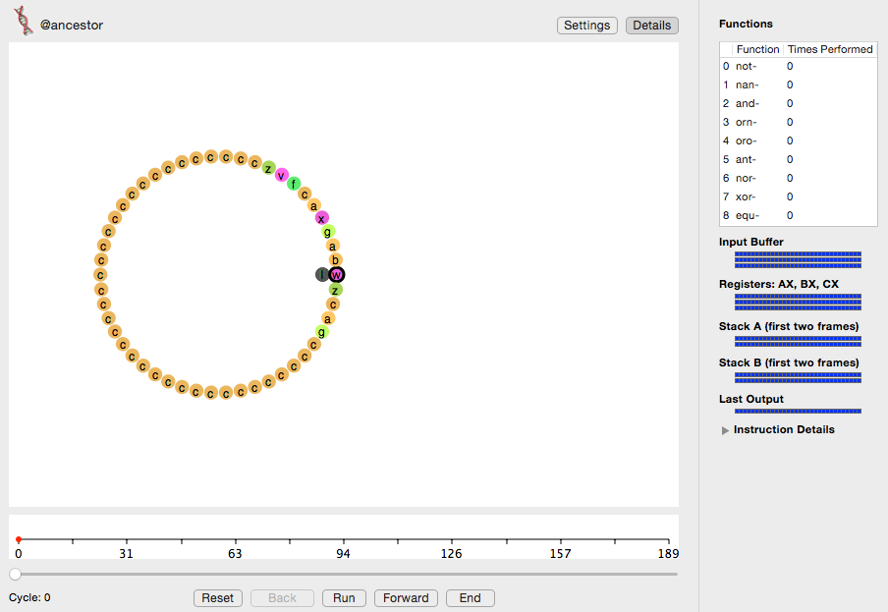
Show/hide viewer settings & org function details
Play /Pause,
Single step,
Beginning & End controls
Time line &
Scrub bar
Organism icon & name
Shows what the genome’s instructions are doing
Shows movie of an org’s genome as it runs

- Organism icon & name: Name of the organism whose genome is being viewed.
- Time line: Shows the cycle number of the instruction being executed and the number corresponding to any function that is completed at that point.
- Run/Stop button: Starts and temporarily stops movie.
- Save images of orgs in viewer [MENU File -> Export Graphics…]

(3) Analyzer Lab Bench (Data graphing & analysis)

Functionality
- Graph one or two data sets from a population.
- Graph and compare data from one to three populations.
- Export selected data for external analysis in Excel or other programs.
- Save viewer images.

Basic Controls
- Drag full Petri dish(s) from the freezer onto the analyzer lab bench.
- Use pull down menus to choose the color for each population and what information you wish to graph (you can graph two properties at once).
- Save images of graphs [MENU File -> Export Graphics…]
- Export selected data to comma-delimited file. [MENU File -> Export Data…]

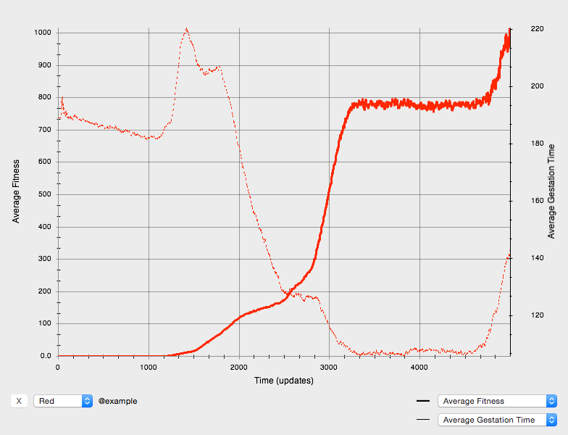
Graph of selected properties of population(s)
Drag full dish anywhere into Analyze window
Set properties to graph and line style
Set color for each population
Population(s) name

(4) Menus

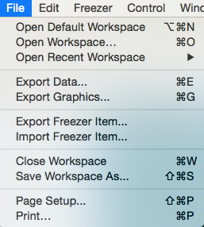 | 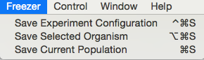
 | 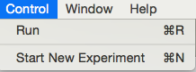

File Menu
- Workspace controls: All the settings and data generated in your workspace may be saved and reopened later.
- Export / Import controls: Data, images, configured and populated dishes, and individual organisms can be separately exported and then later imported into another workspace or used by some other program.

Freezer Menu
- Petri dish environmental configurations, individual selected organisms, or entire populated Petri dishes in your workspace may be saved to the freezer for later resuse.

Control Menu
- Run/Pause a population that is set up in the Petri Dish.
- Start New Experiment: Discard or save the current setup and start a new experiment

Glossary

Avida
Pronounced Aveeda. From A-life (artificial life) in Spanish (vida = life). Avida is the evolutionary computation engine at the heart of Avida-ED.

Avidian
Pronounced Ah-vîd-ian. An organism in the Avida environment.

Death
In Avida-ED, an Avidian will die of “old age” if it does not self-replicate within a given number of instructions, set here as 20 times its genome length. It may die earlier if another Avidian divides and one of the daughter cells is placed by chance onto its spot on the grid, overwriting it.

Fitness
Measured in Avida as metabolic rate divided by gestation time. Holding the environment constant, if organism X has twice the fitness of organism Y, it means that it, on average, X will reproduce twice as fast as Y. This fitness measure is objective, in that it measures non-relative things (metabolic rate and gestation time). It is important to realize that, in terms of natural selection, the fitness of an organism must be compared to the organisms it competes with. An organism with a fitness of .3 will have a selective advantage in a population where every other organism has a fitness of .1, whereas this same organism with a fitness of .3 will be at a selective disadvantage in a population where every other organism has a fitness of 10.

Genome
This is the genetic code of an Avidian. It consists of a ‘string’ (list) of instructions comprised of the instruction set. Its biological analogy is an organism’s DNA. In Avida-ED the size of the genome is fixed at a length of 50 instructions.

Gestation
The number of instructions it takes for an organism to reproduce.

Instruction Set
The genome of an Avidian is comprised of a series of simple computer instructions. There are 26 instructions in the basic set. Different instructions are symbolized by the lower-case letters “a” through “z” and by different colored dots in the organism viewer.

Metabolic Functions
Organisms may gain additional energy by evolving abilities to perform special “metabolic” functions or tasks. These tasks are logic functions performed on either one or two 32-bit numbers. The organism must manipulate these numbers with the instructions in its genome. In Avida-ED there are 9 functions that that may be evolved (not, nand, and, or_not, or, and_not, neither_or, exclusive_or, equals). All functions require some complex sequence of instructions to perform. The simplest of these functions (not) takes a minimum of 6 instructions (we think). The most complex tasks (exclusive or, equals) take a minimum of 19 instructions (we think). The ability to perform a task multiplies the org’s basic metabolic rate by the task’s energetic value.

Metabolic Rate
Each organism has a value called metabolic rate associated with it, which indicates how fast the organism is able to execute instructions. Metabolic rate is a unitless quantity —“merit”—and is only meaningful when compared to the merits of other organisms. Thus, if organism X has twice the merit of organism Y than X should execute twice as many instructions in any given time frame. Therefore, if the gestation times of X and Y are the same, and X has twice the merit of Y, then, on average, X will reproduce twice as fast as Y (see also fitness).

Mutation Rate
This percent chance that an instruction will be copied incorrectly. So, if the per site mutation rate is 1%, there is a 1% chance that when an instruction is copied, it will end up as any one of the 26 possible instructions (one of which is itself, so it could ‘mutate’ back to itself). With a 1% per site mutation rate, if 100 instructions are copied one of them will be mutated on average (although this number could be higher or lower in any instance). What mutations will occur is determined by a random number generator and will be different each run unless the demo mode is checked to force exact repeatability. In Avida-ED 1.0 only point mutations are allowed but no deletions or insertions in order to keep the genome at a uniform size to preserve legibility.

SIP (Single Instruction Processing unit)
A unit of “energy” in Avida. [Not yet explicit in Avida-ED]

Time
Avida time is internally constant and is measured in “updates”. Avida standard time is not constant relative to real time; a single update for a large population takes longer in real time than an update for a small population.

Update
An “update” is the unit of time in Avida-ED. Avida time is internally constant, but is not constant relative to real time; a single update for a large population takes longer in real time than an update for a small population. “Update” is defined as the passage of enough SIPS (executions of single instructions) such that each organism, on average, has executed 30 instructions (however, more fit organisms will most likely have executed more and less fit organisms will have executed fewer).

